White to play.
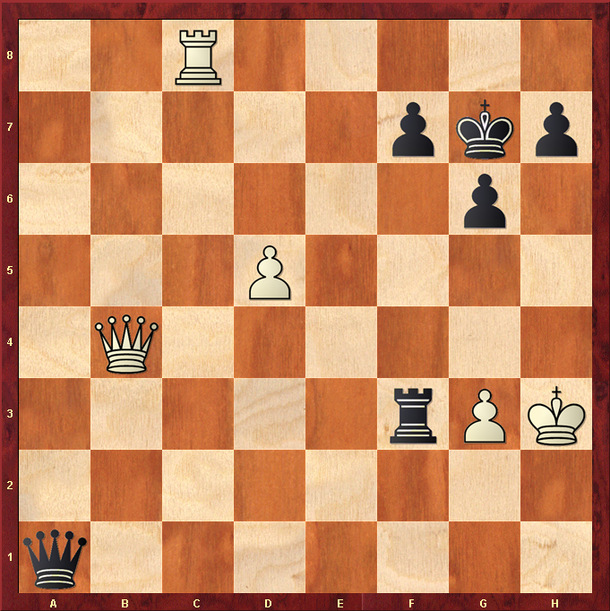

Hint : Get close and force a skewer …

