White to play.

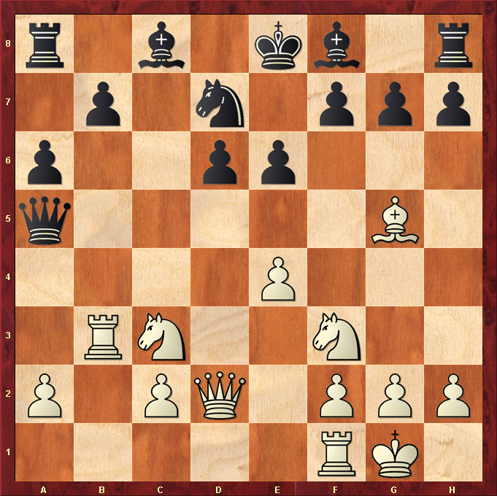

Hint : Black King is penned in, just need a piece to deliver check …

