Black to play.

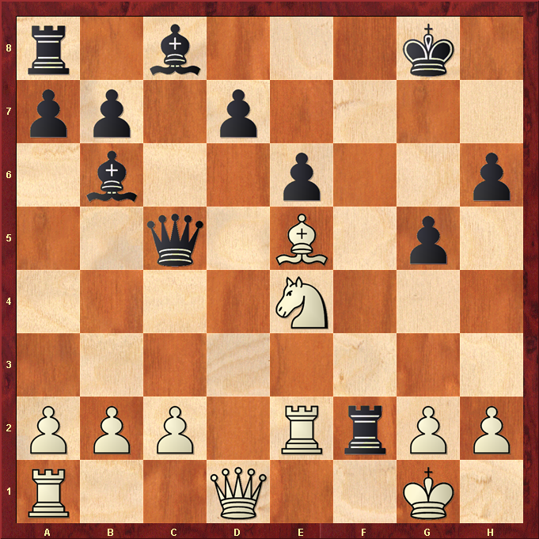

Hint : Black Queen is under attack from the Knight so Black must be careful when moving Rook !

