Black to play.

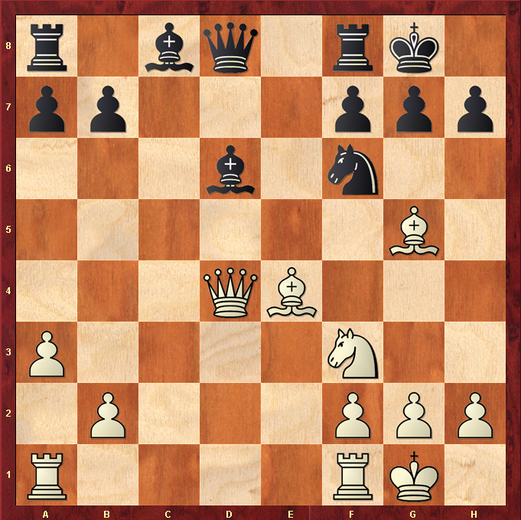

Hint : Sometimes, winning a Pawn can be enough …

