White to play.
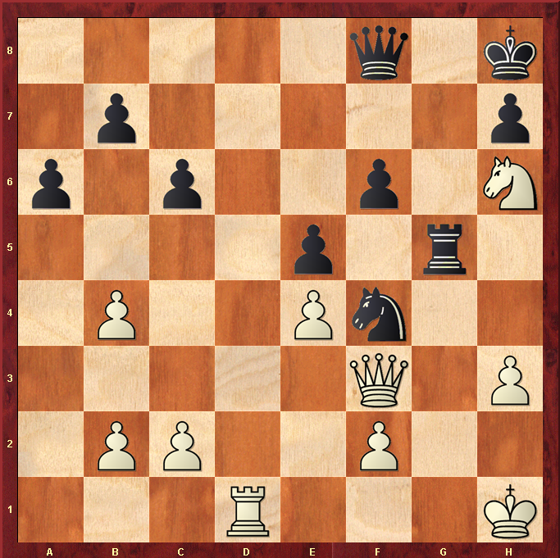

Hint : Royal family …

