Black to play.

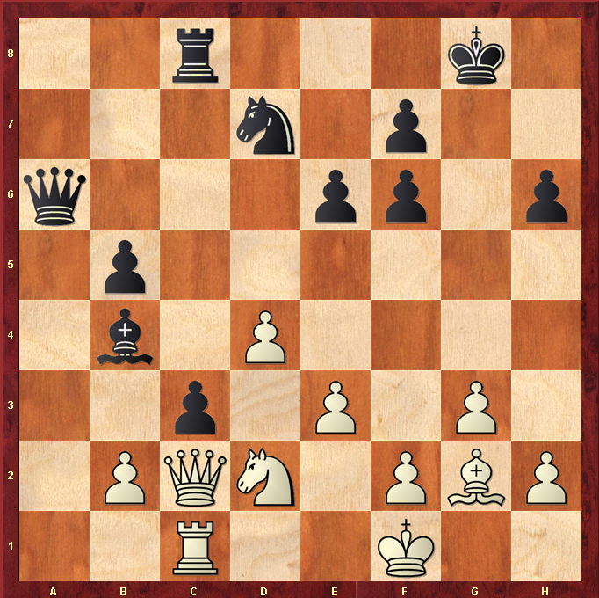

Hint : Push Pawn up… can White stop it ?

