White to play.

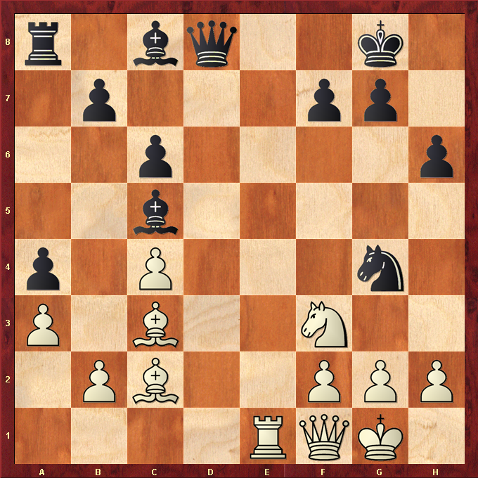

Hint : Force Black Queen off the back line ….

