White to play.

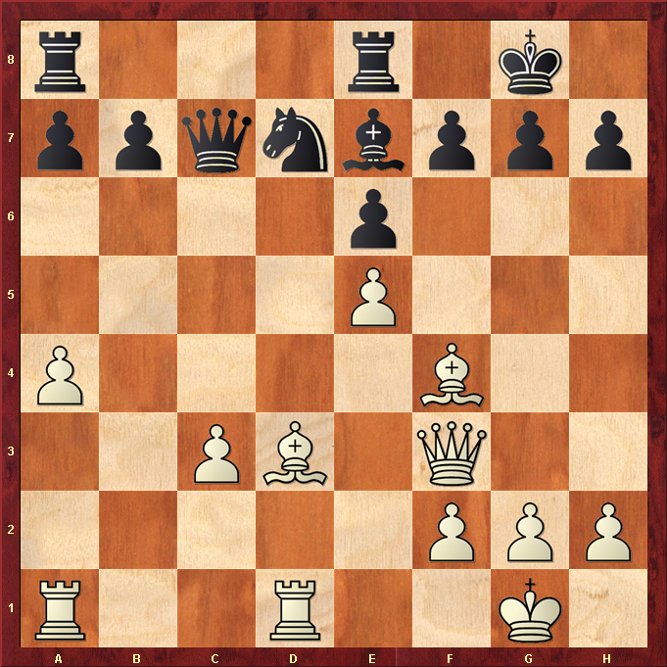

Hint : Bishop decoy sacrifice wins a pawn ….

