Black to play.

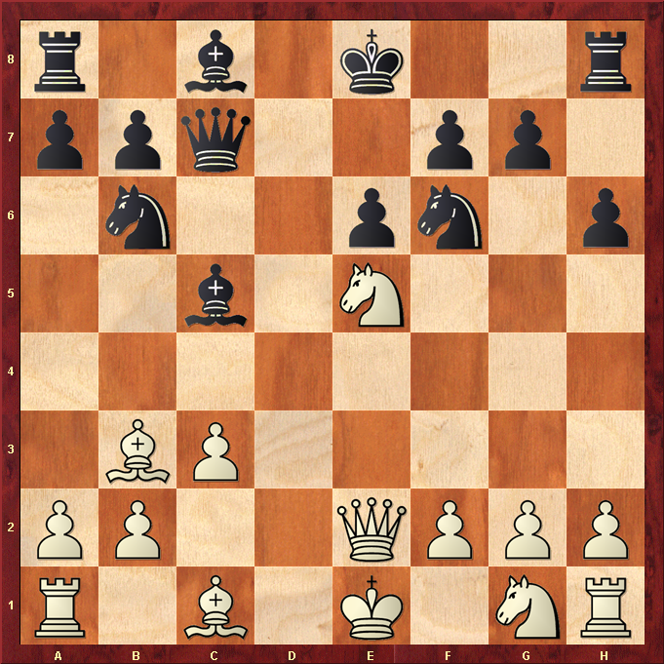

Hint : Think White King on f2 and White Queen on e5 ?

