White to play.

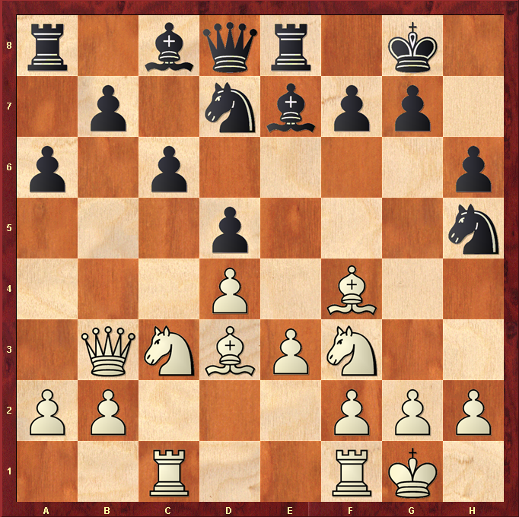

Hint : Queen trap ….

