White to play.
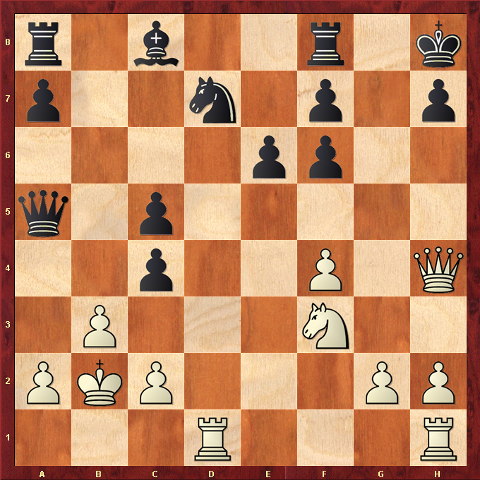

Hint : White is a piece down so a draw would be good for white …

