White to play.

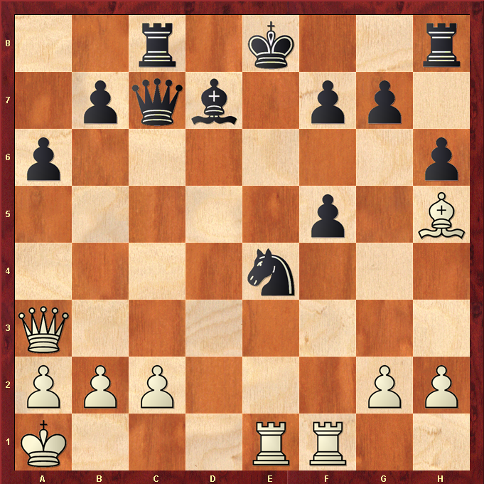

Hint : White would like to get a rook in to the action ….

