White to play.

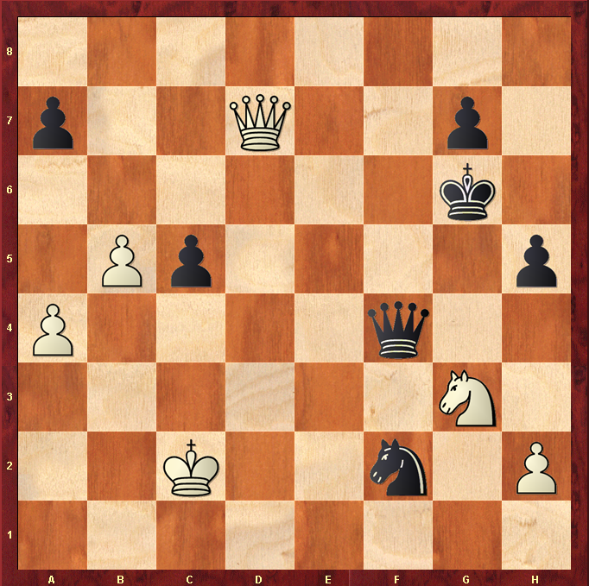

Hint : Queen sacrifice can win 2 pawns ….

