Black to play.

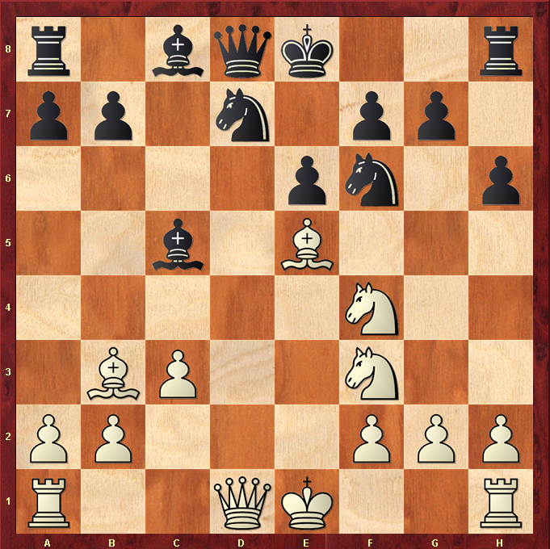

Hint : Bishop sacrifice wins a pawn ….

