White to play.
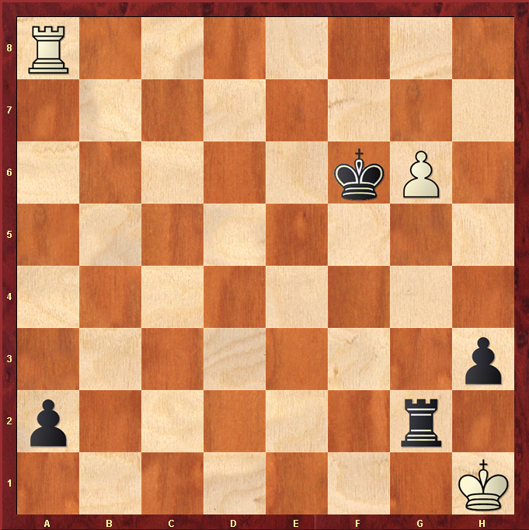

Hint : White is a pawn down with his Rook tied up with a2 pawn, can he salvage anything ?

