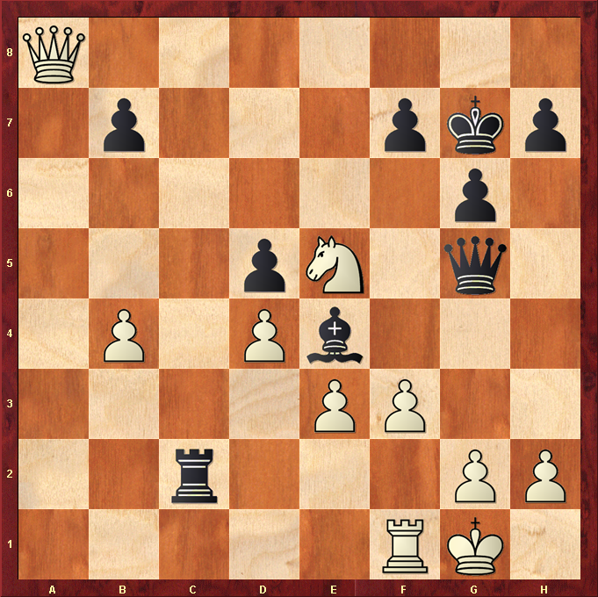
White to play.

Hint : Queen counter attack ?

