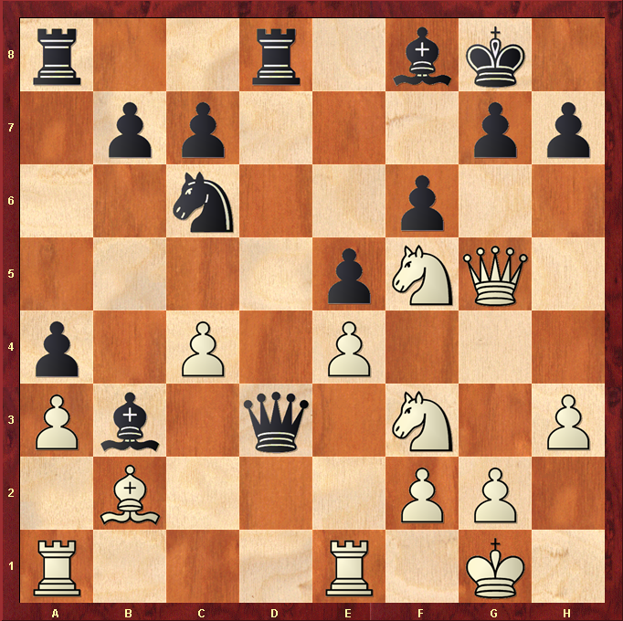
White to play.

Hint : White is a piece down, a draw would be ok ?

