Black to play.

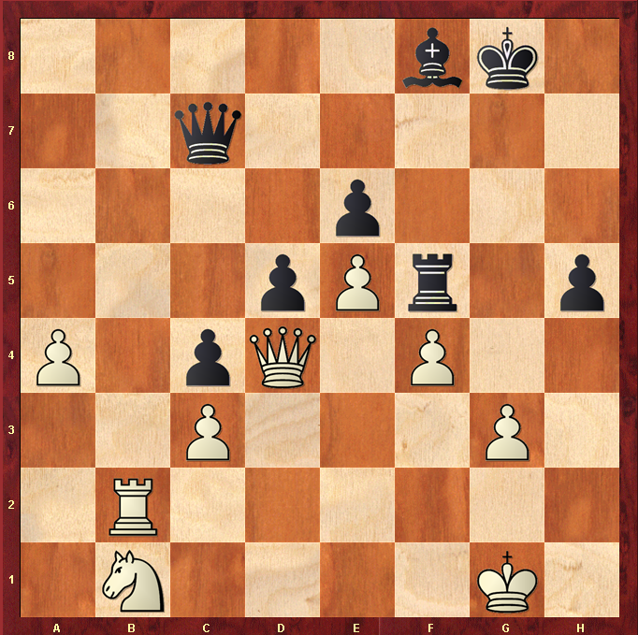

Hint : Look for the lines ….

