Black to play.
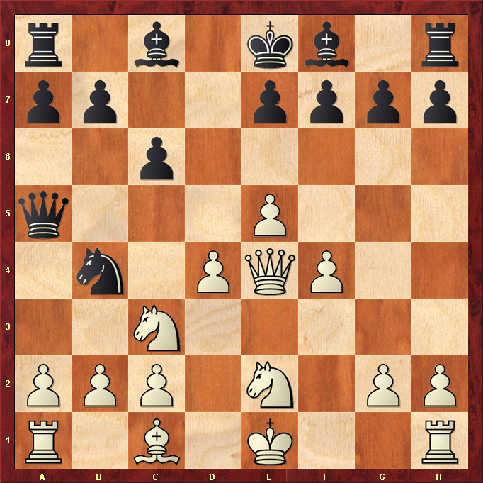

Hint : How can you get your Knight to C2 to win the exchange ?

