White to play.

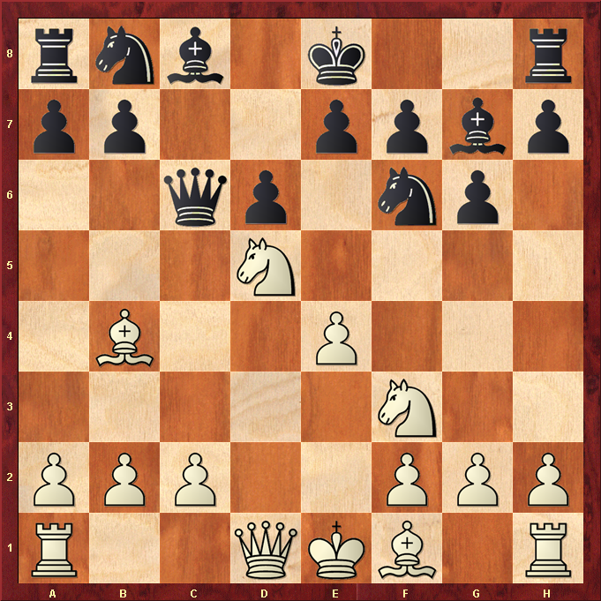

Hint : Queen and King look ripe for an attack !

