Black to play.
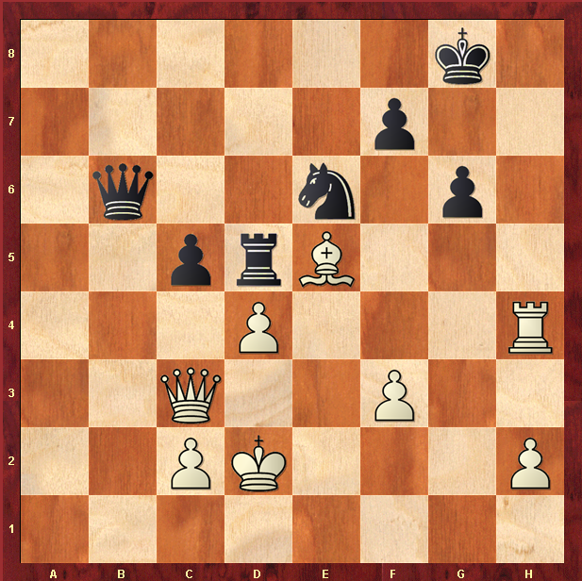

Hint : Black Queen forks King and Rook

