Black to play.

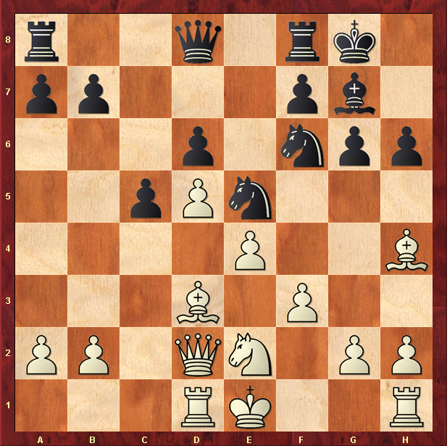

Hint : Break the pin

