Black to play.

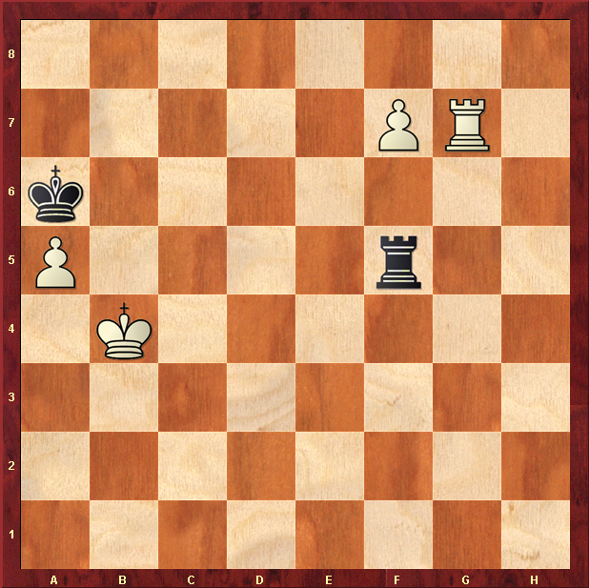

Hint : Black is 2 pawns down so would be happy with a draw

