White to play.

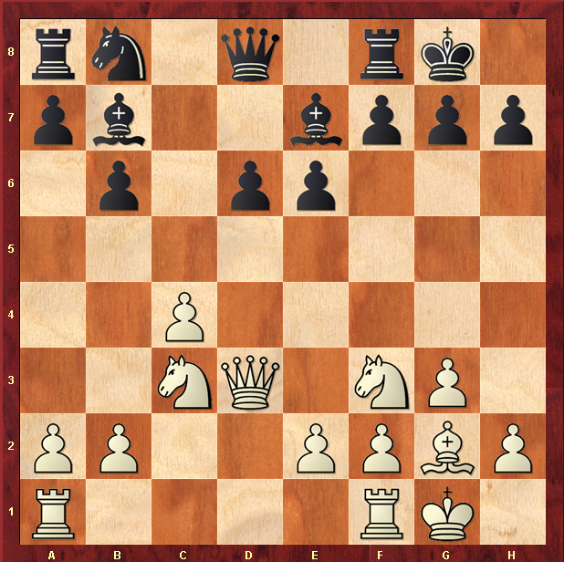

Hint : Double attack wins Rook

