Black to play.

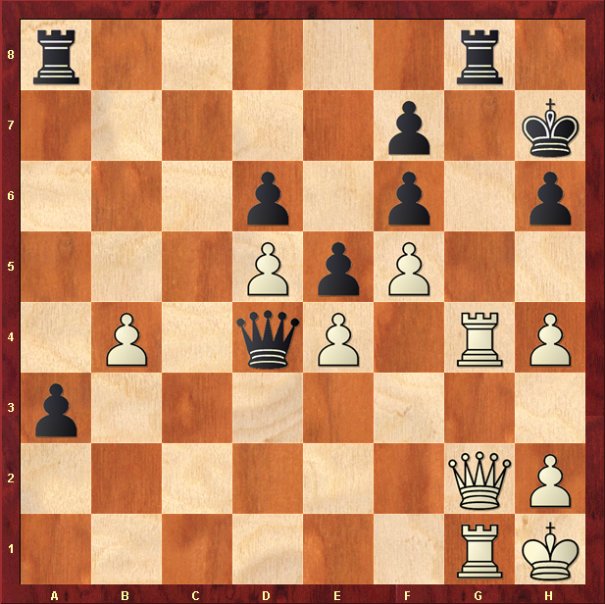

Hint : Black is in trouble, whites Rook-Queen-Rook attack may mate soon …

