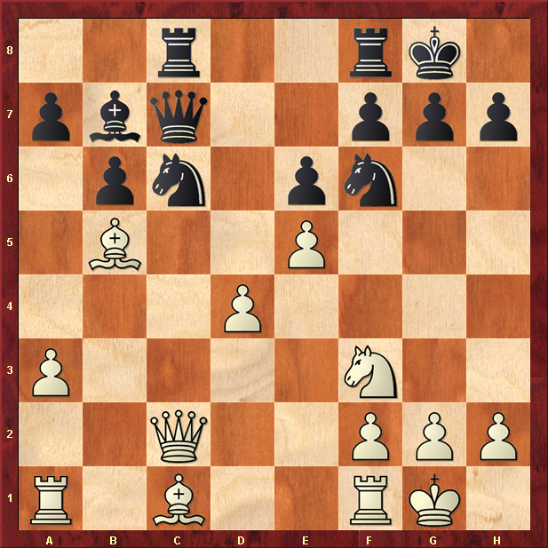
Black to play.

Hint : Knight attack wins a pawn

