White to play.
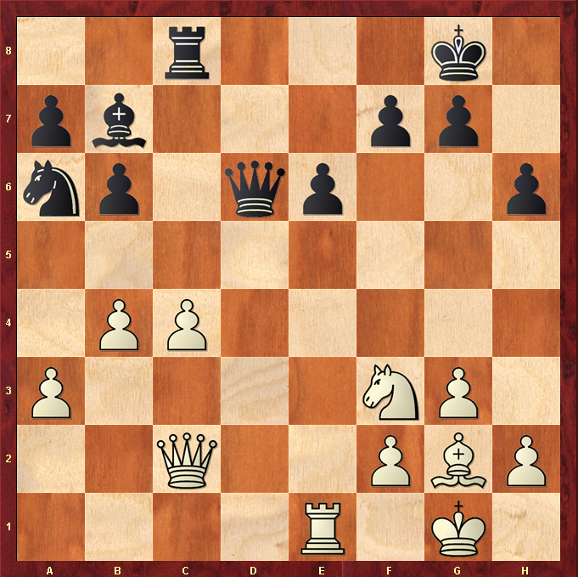

Hint : Think Queen to h7 .. What happens when Knight moves ?

