White to play.
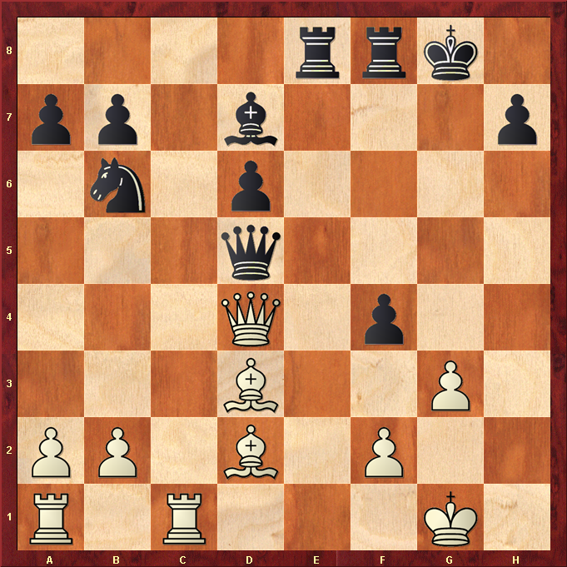

Hint : Always look for horizontal and diagonal lines …. ☺

