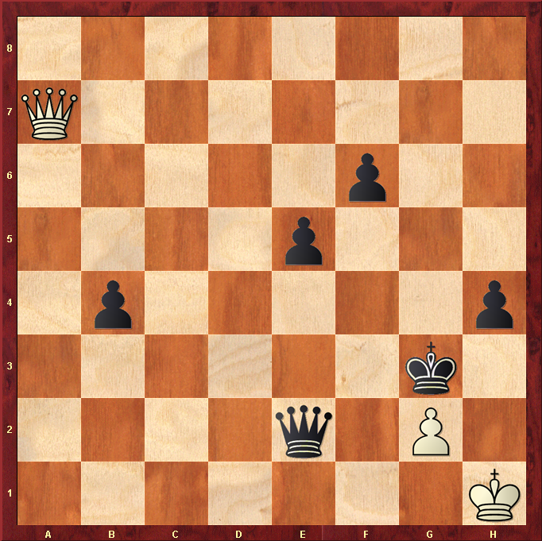
White to play.

Hint : White looks likely to lose this game so a draw would be good ??

