White to play.

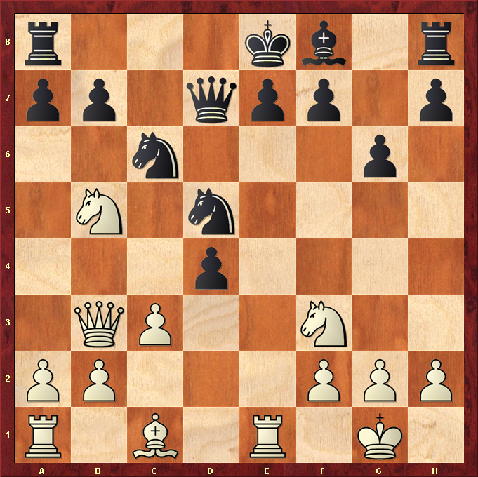

Hint : Knight on c7 would be good …

