White to play.
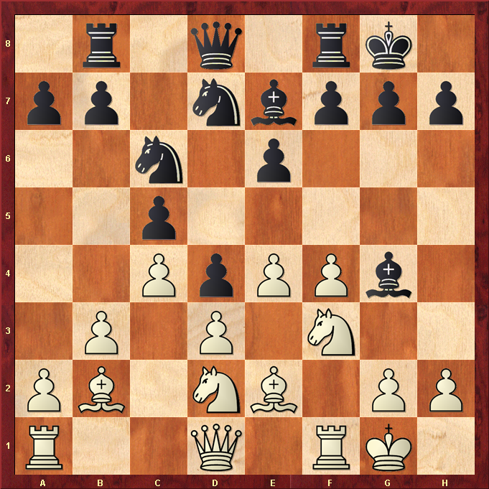

Hint : Elastic band wins a pawn …

