Black to play.

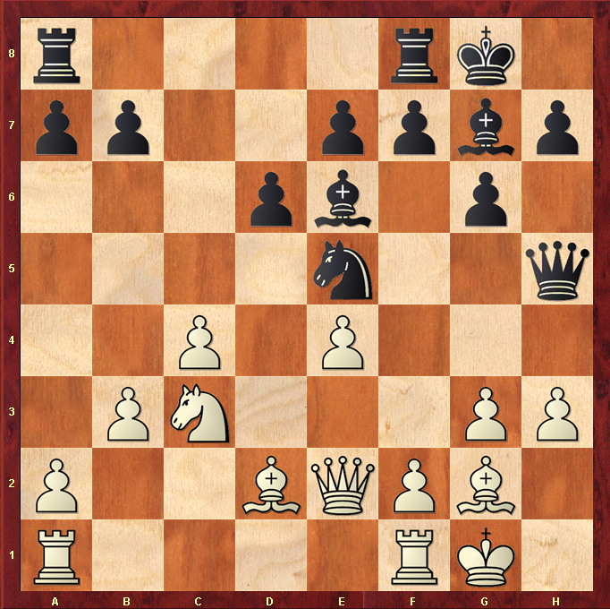

Hint : Knight fork on d2 Bishop may win a measly pawn, but opens the h-file !

