Black to play.

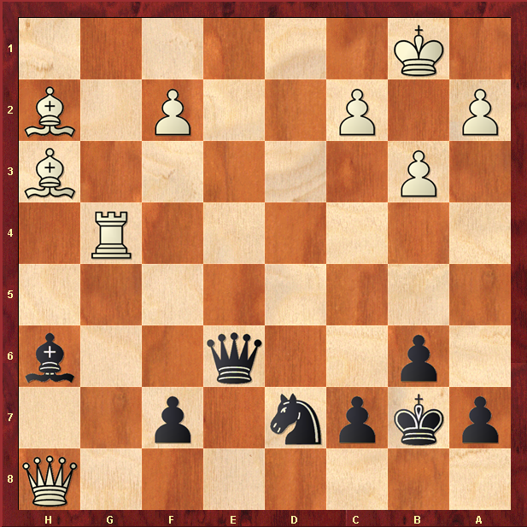

Hint : Skewers, forks and pins galore !

