Black to play.

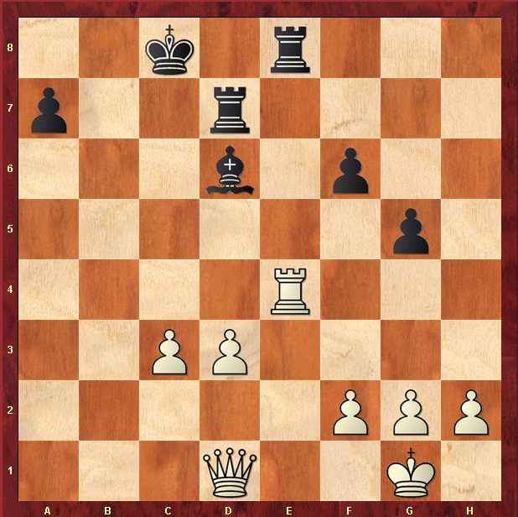

Hint : See d1 Rook lining up on White Queen …

