Black to play.

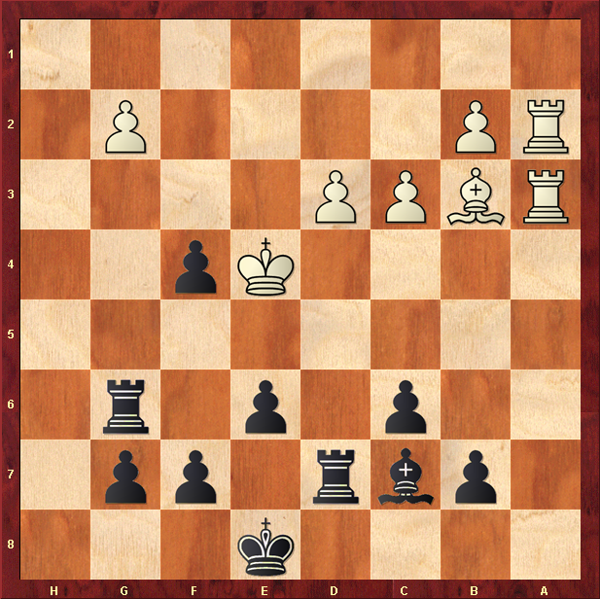

Hint : Box the King in …

