Black to play.
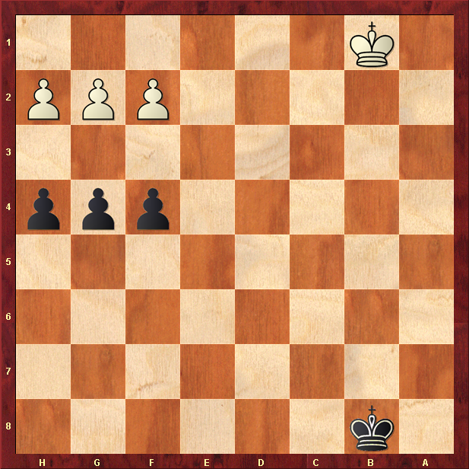

The “Russian” Position.

