Black to play.

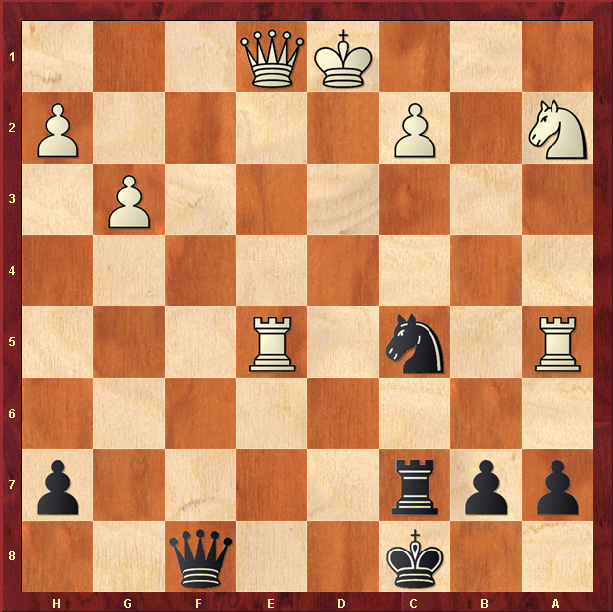

Push King to c1 ?

