Black to play.
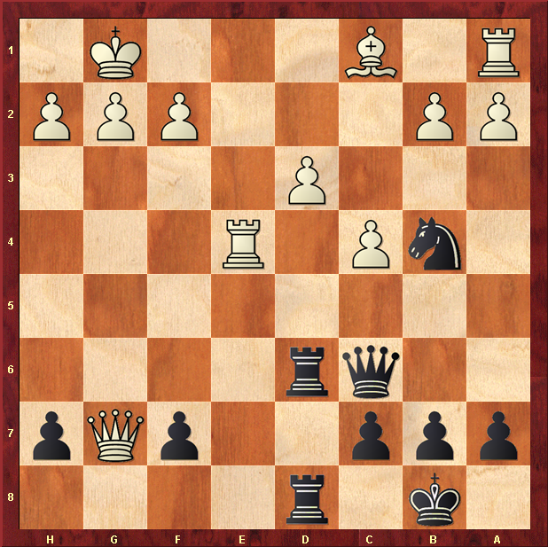

Hint : Notice Black has double Rooks pushing down the d-file…

