010 White to Move
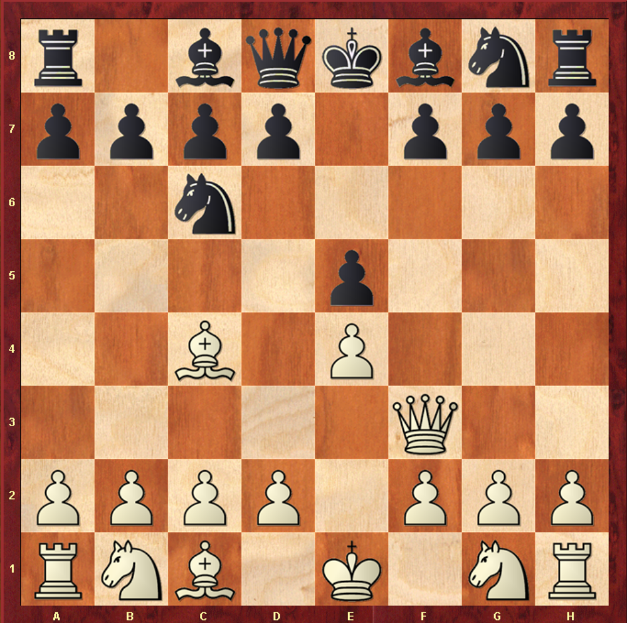

Solution - QxF7#

- White Queen moves up and takes pawn at F7 – Checkmate.
- This is known as “Scholars Mate” or “4 Move Checkmate”
- Squares at E8 and E7 are covered by the White Queen, so Black cannot move out of check
- Black King cannot take the Queen because White Bishop at C4 protects the Queen from the King.

