030 White to Move

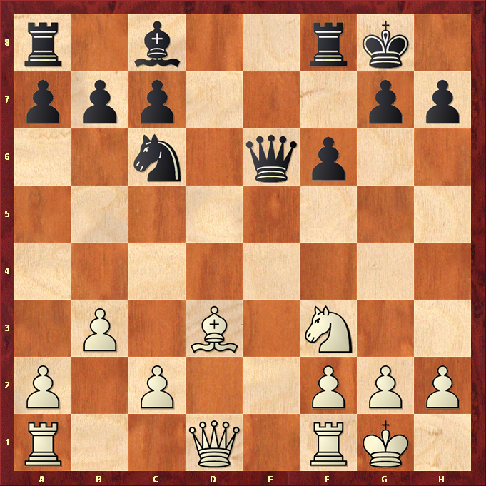

Best Move – BC4
- White Bishop “Pins” the Black Queen to King
- Black Queen cannot move out of the Bishops path because his King would be revealed, which would be check and therefore not allowed.
- Black has no pieces that he can block the attack with ( moving any piece to D5 would have been good for black )
- White will win blacks Queen ( 9 points ) in exchange for a bishop ( 3 points )

