050 White to Move

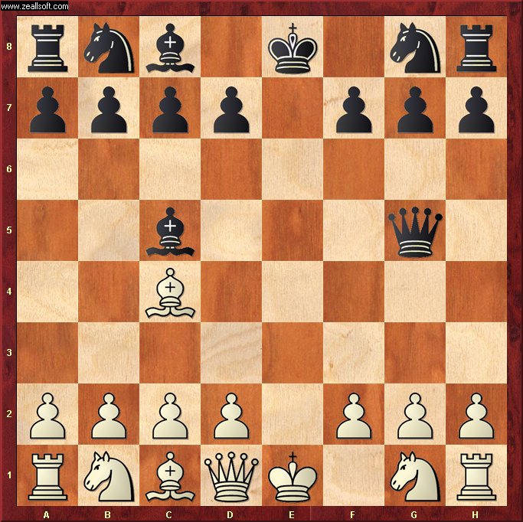

Best Move – D4 (Pawn to D4)
- White attacks the Black Bishop with Pawn.
- But this conceals a nasty “Revealed Attack” on Black Queen by White Bishop at C1
- Black may spot the pawn attack on his Bishop and save his Bishop … and lose his Queen !
- Or Black may spot the revealed bishop attack and save his Queen … but lose his Bishop !
- Either way, White wins a piece. ☺

