053 White to Move
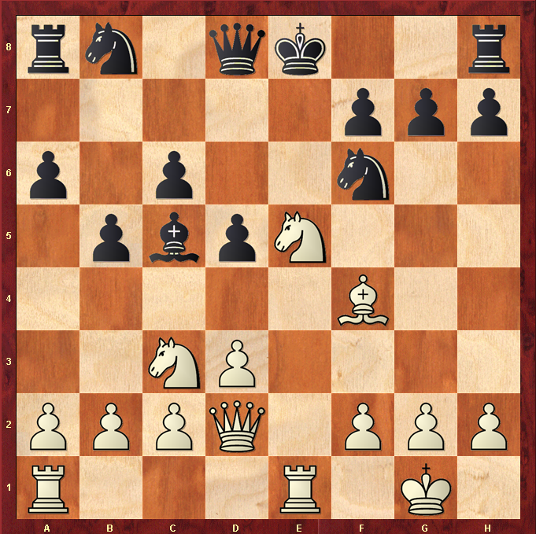

Best Move – Nc6+!
- White Knight to c6 attacks the Queen but also reveals check on Black King by White Rook !
- Black must counter the check, whatever he does he will lose his Queen
- If Black moves King, White Knight takes Queen
- If Black Be3, White Queen will take B as a gift and Black is still in check
- If Black Ne4 Blocking and Counter attacking White Queen then RxN and Black is still in check
- Black is in big trouble and has no obvious reply.
- Black should earlier have castled King to safety !

