062 White to Move
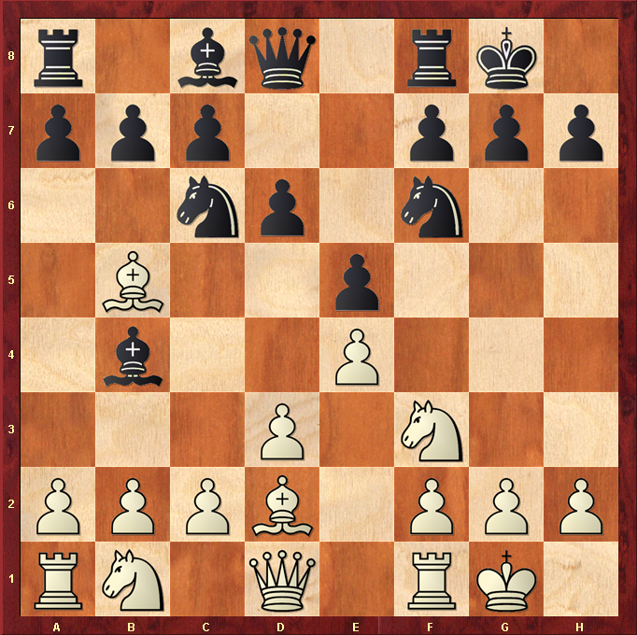

Best Move – BxN
- Black Knight on c6 is defending Bishop on b4
- White bishop takes Black Knight. Black may retake Bishop with b-pawn ( swapoff )
- This leaves Black Bishop undefended
- White may win a Knight and Bishop for a Bishop
- This is known as “remove the defender”

