109 White to Move
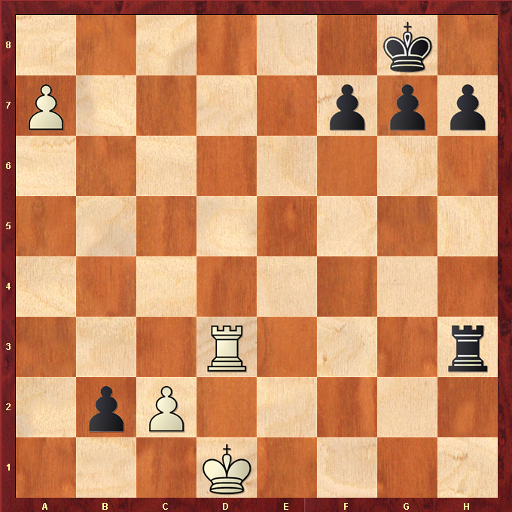

Solution – A8Q#

Pushing A Pawn to 8th Rank promotes to a Queen and checkmates the Black King on Back Rank.

D3 Rook take H3 Rook looks tempting, but this would result in Black B Pawn promoting and Black would likely win.

Always push a passed Pawn, the side that gets a Queen back will likely win.

