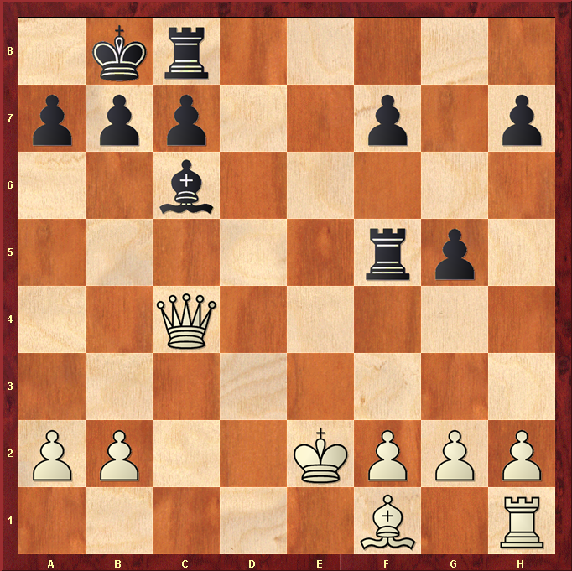
503 White to Move – Qd3 ?

