Pos002 - Who has the better position

Why ?

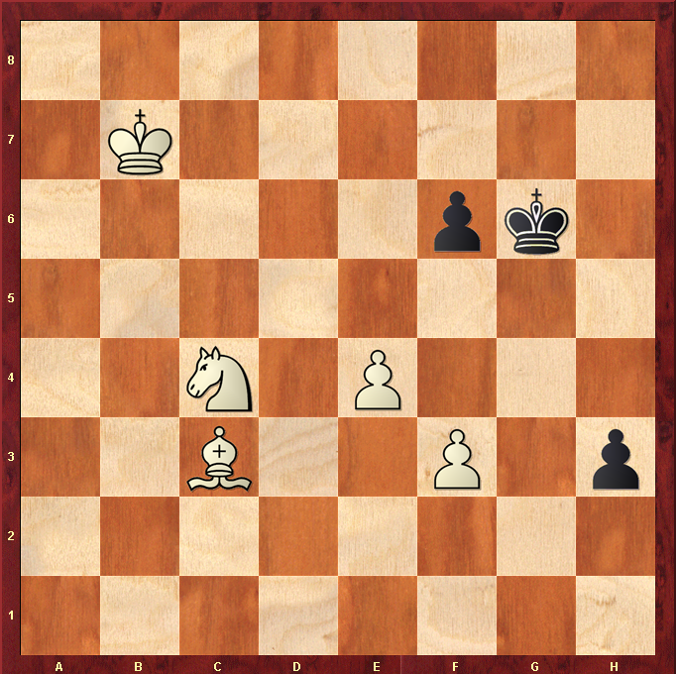

Hints :
Pawn promotion ?

