Top Ways to Win Pieces

UNGUARDED
Your opponent may leave unguarded pieces! Look !

OVERPOWER
More pieces attacking than defending. Always take piece value into account. P=1, B=3, N=3, R=5, Q=9.


FORK
Attacking 2 pieces at once. Knights especially good.

PIN
Attack a piece with a valuable piece behind it.

SKEWER
Opposite of a pin with big piece in front
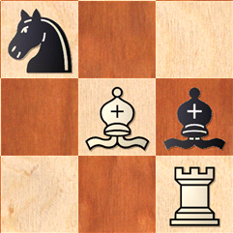
REMOVE DEFENDER
A defending piece swapped off or
chased away may leave a unguarded
piece. Buy-one-get-one-free.

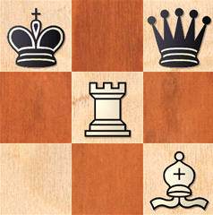
REVEALED ATTACK
The best ! Moving a piece reveals an
attack on another piece.

