107 Black to Move
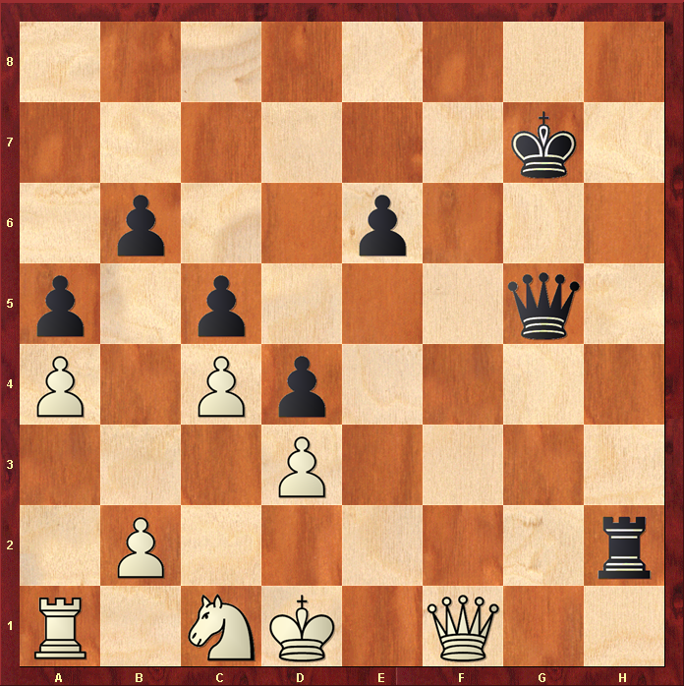

Best Move – QD2#
- Black Queen comes up close to the White King to Block off all surrounding squares
- White King cannot take the Queen because it is “protected” by Black Rook at H2
- White cannot block because there are no gaps
- White has no pieces that can take the Queen
- Black Mate ( shown as “#” is chess notation )

- … Always try to protect and bring your Queen close to the King when looking to checkmate !

