| #1: Using Cancer Re-Occurrence File, create and submit your own dot plot library(ggformula) cancer_recurance_url <- 'https://raw.githubusercontent.com/kathrynKozak/MAT160/master/docs/cancer_recurance.csv' cancer_recurance <- read.csv(cancer_recurance_url) gf_dotplot(~ tummor, data = cancer_recurance, title='Tumor Recurrence After Chemotherapy') +  theme_minimal() |
| --- |

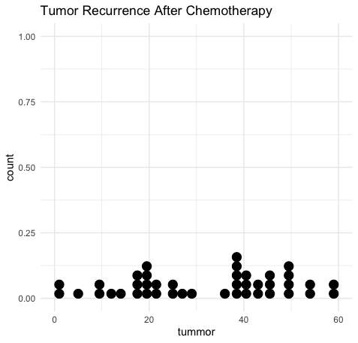

| #2: Using the cancer file, give the mean, standard deviation, variance, and five-number summary.  cancer_url <- 'https://raw.githubusercontent.com/kathrynKozak/MAT160/master/docs/cancer.csv' cancer <- read.csv(cancer_url)  mean_survival <- df_stats(~survival, data=cancer, mean) median_survival <- df_stats(~survival, data=cancer, median) sd_survival <- df_stats(~survival, data=cancer, sd) summary_survival <- df_stats(~survival, data=cancer, summary)  gf_boxplot(~survival, data=cancer, title="Cancer Survival Boxplot", color="blue", outlier.color = "red") +  gf_refine(coord_flip())+  gf_theme(theme_minimal()) |
| --- |

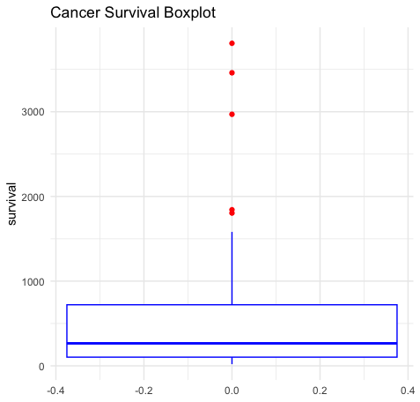

| #3: Using the Cancer Re-Occurrence File, do a histogram chart gf_histogram(~tummor, data=cancer_recurance, title='Cancer Re-Occurence Histogram',  color='lightblue',fill='lightblue', alpha=0.9)+  gf_theme(theme_minimal()) |
| --- |

