How to run:

Go to BillhubApplication.java and run the program (back-end). Then move into the BillHub directory and run the following command: “npm start” which would then launch the front end of the website.

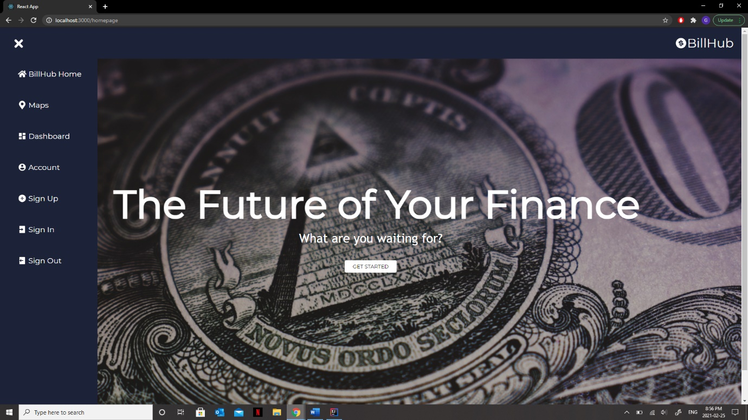Navigation bar:

Google Maps:

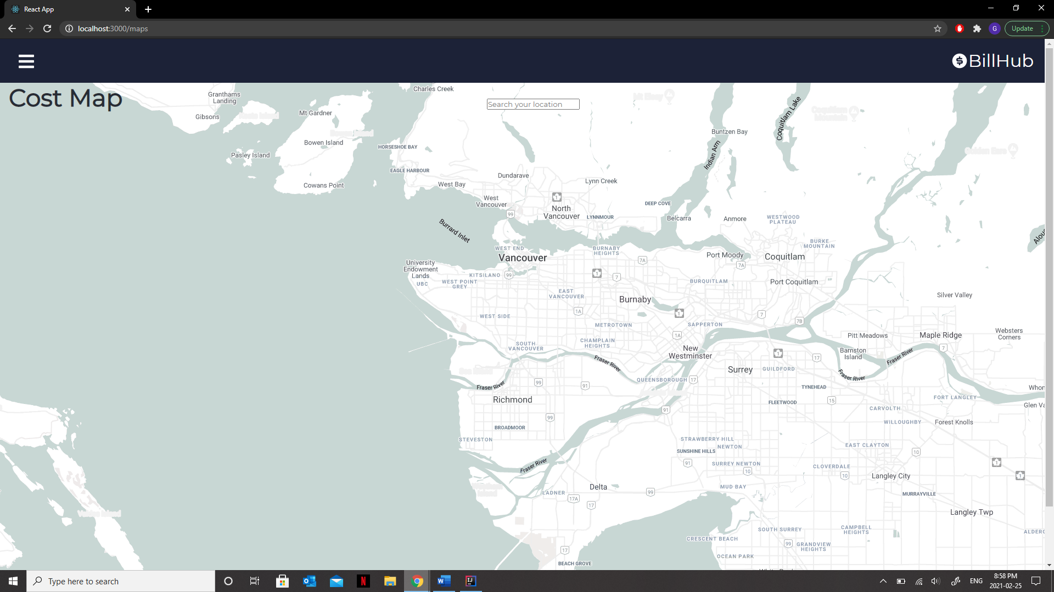

Login:

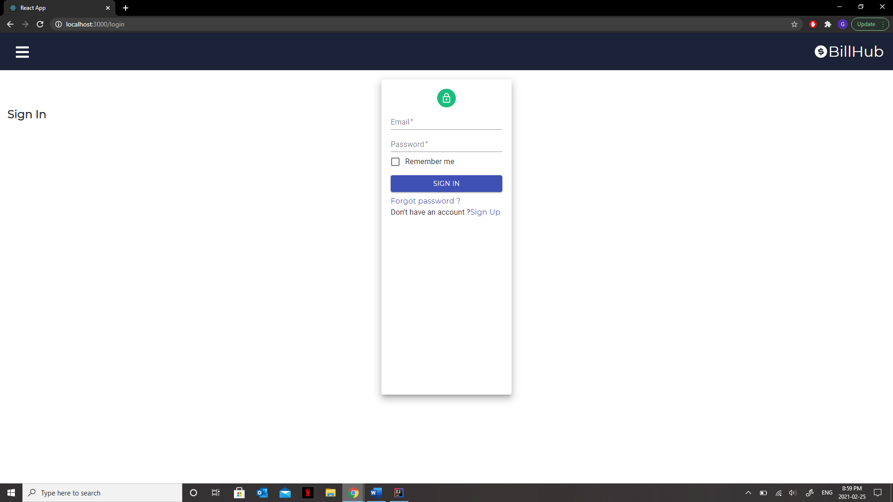

Dashboard with file saving features:

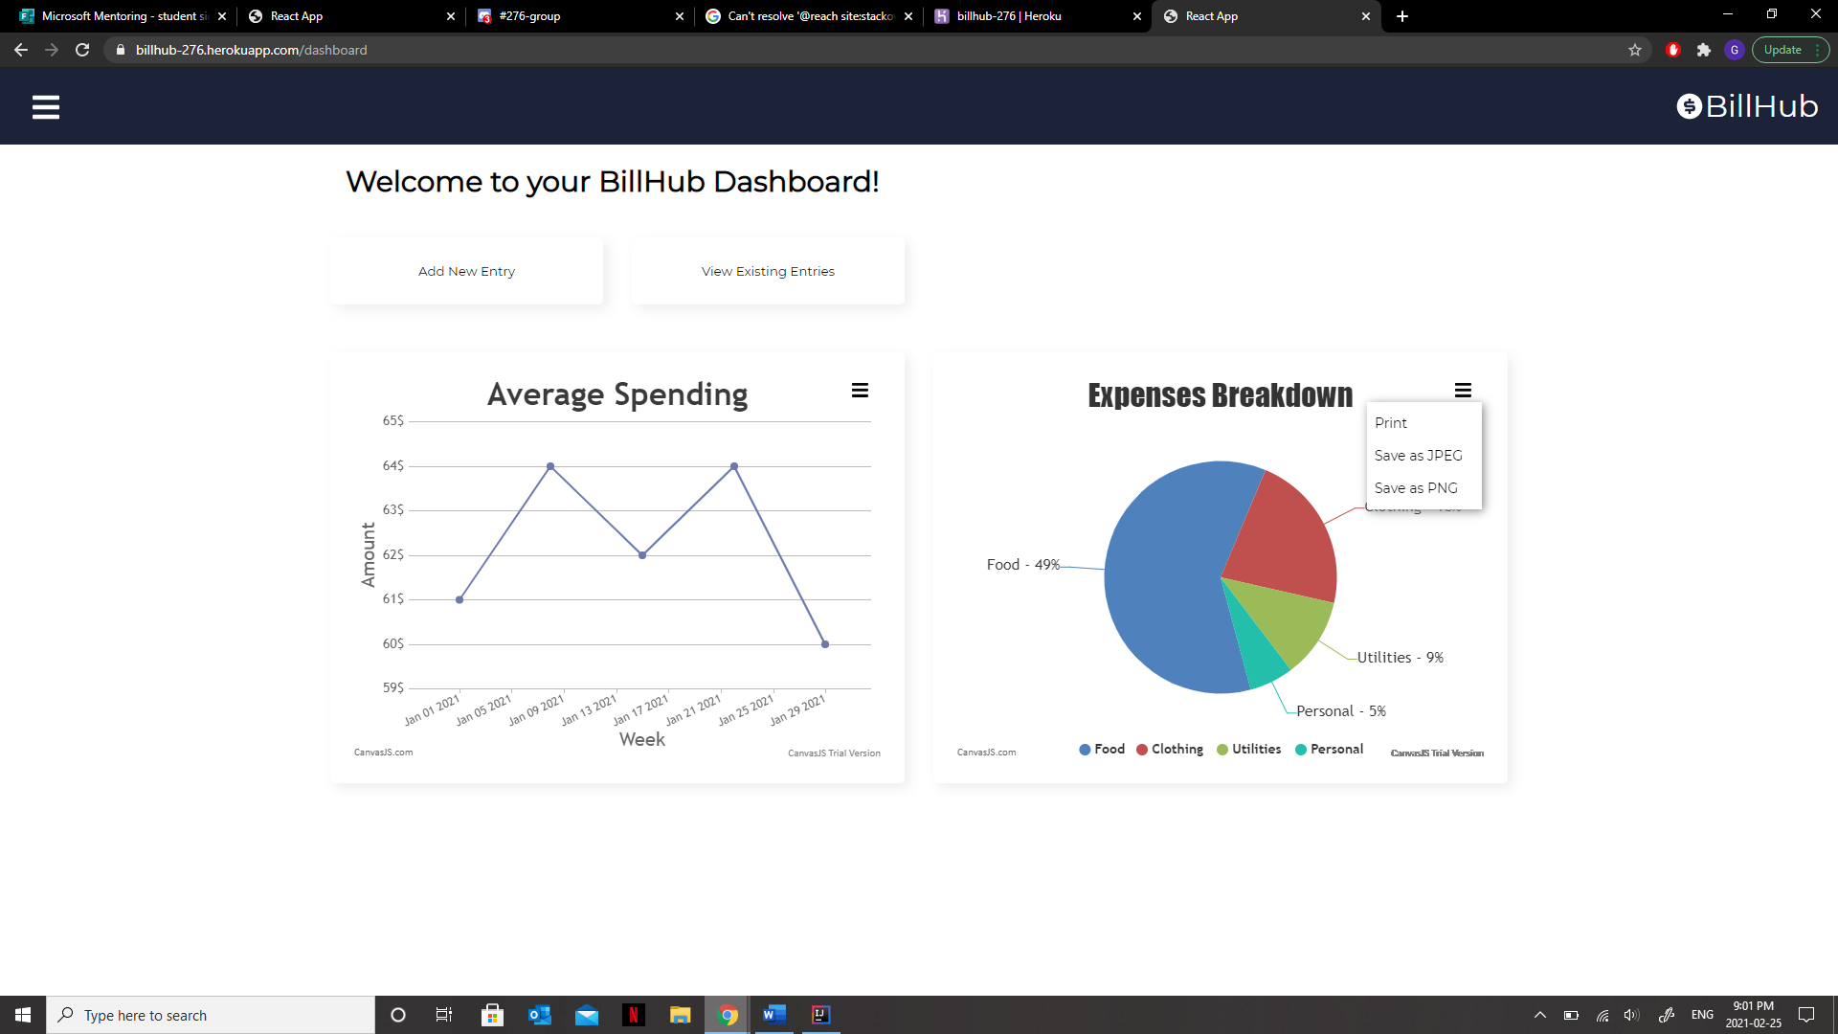

Sign-up:

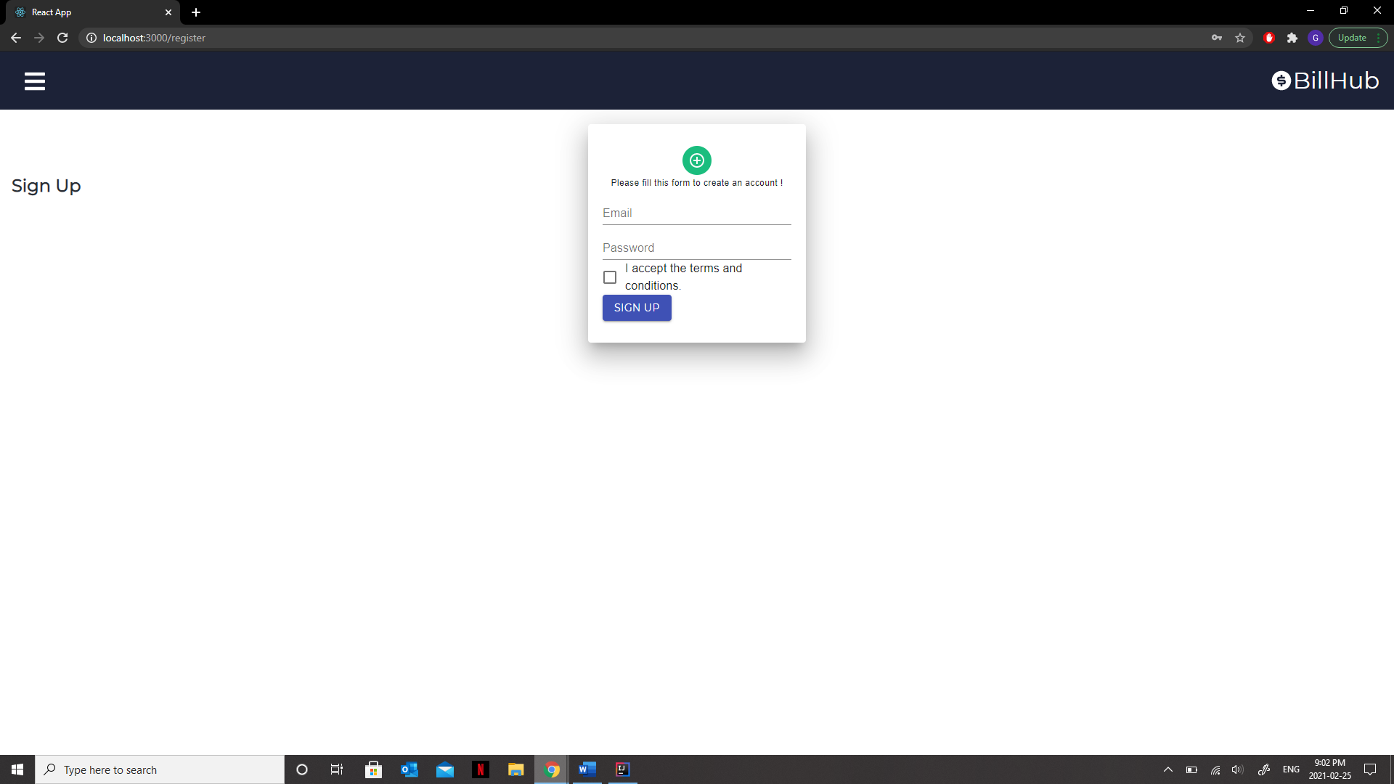

Add new entry:

